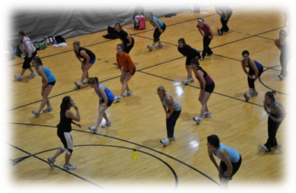
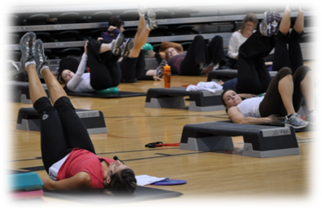
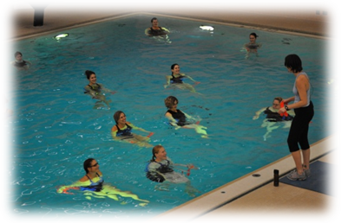
Engage Your Community in Physical Activity…
…BECOME A FITNESS LEADER!
If you can check off at least 2 of the following, consider this training opportunity!
- You used to be a Fitness Leader
- You are physically active
- You love to inspire and motivate others
- You have passion and enthusiasm for physical activity and fitness
<<Organization Name>> is now accepting registrations for Fitness Leadership Training through the Saskatchewan Parks and Recreation Association (SPRA) Fitness Leadership Certification Program. We are looking for individuals who want to discover new and rewarding employment opportunities. Training will be offered so you can become a certified fitness leader within your community to empower others to lead healthy, active lifestyles!
SPRA is recognized as the provincial certifying organization for Fitness Leaders in Saskatchewan and presents a full program of Fitness Leadership Certification courses throughout the year. SPRA is represented on the National Fitness Leadership Alliance (NFLA). For more information on certification details, visit www.spra.sk.ca/fitness. To register or find out more, call <<Organization Phone>> or email <<Organization email>> by <<Deadline>>.

Become a Fitness Leader and let’s get communities active!

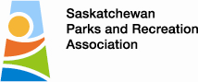 |  | 

